INTERIOR DESIGN:

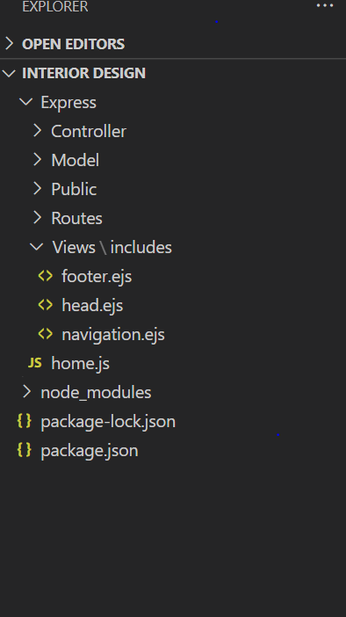

Here made the folders . MVC model , view , controller . After that we have routes.

Public have css, img, js .

Includes will have the common code of all the pages which we are using.

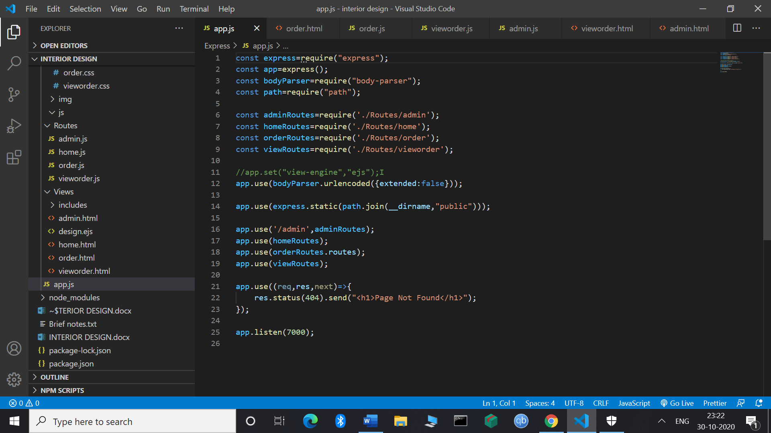

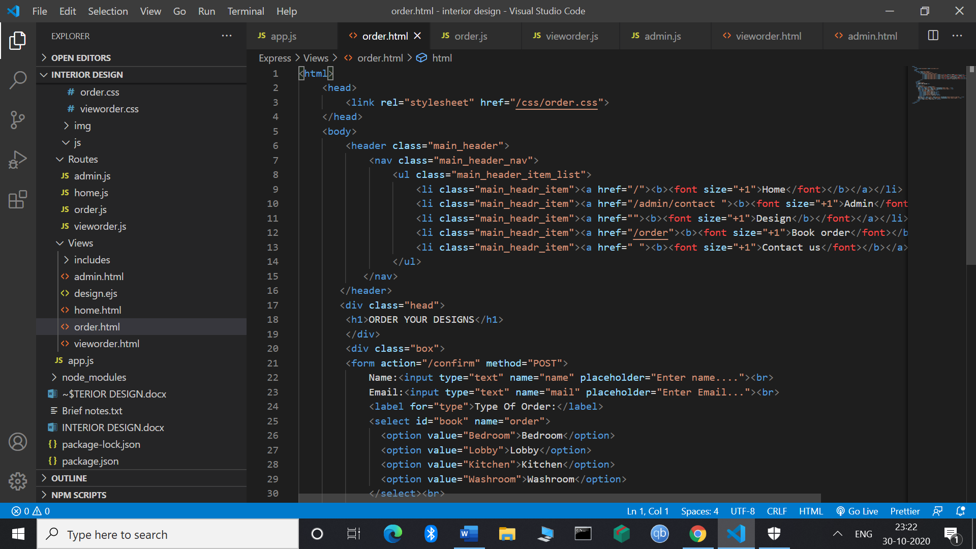

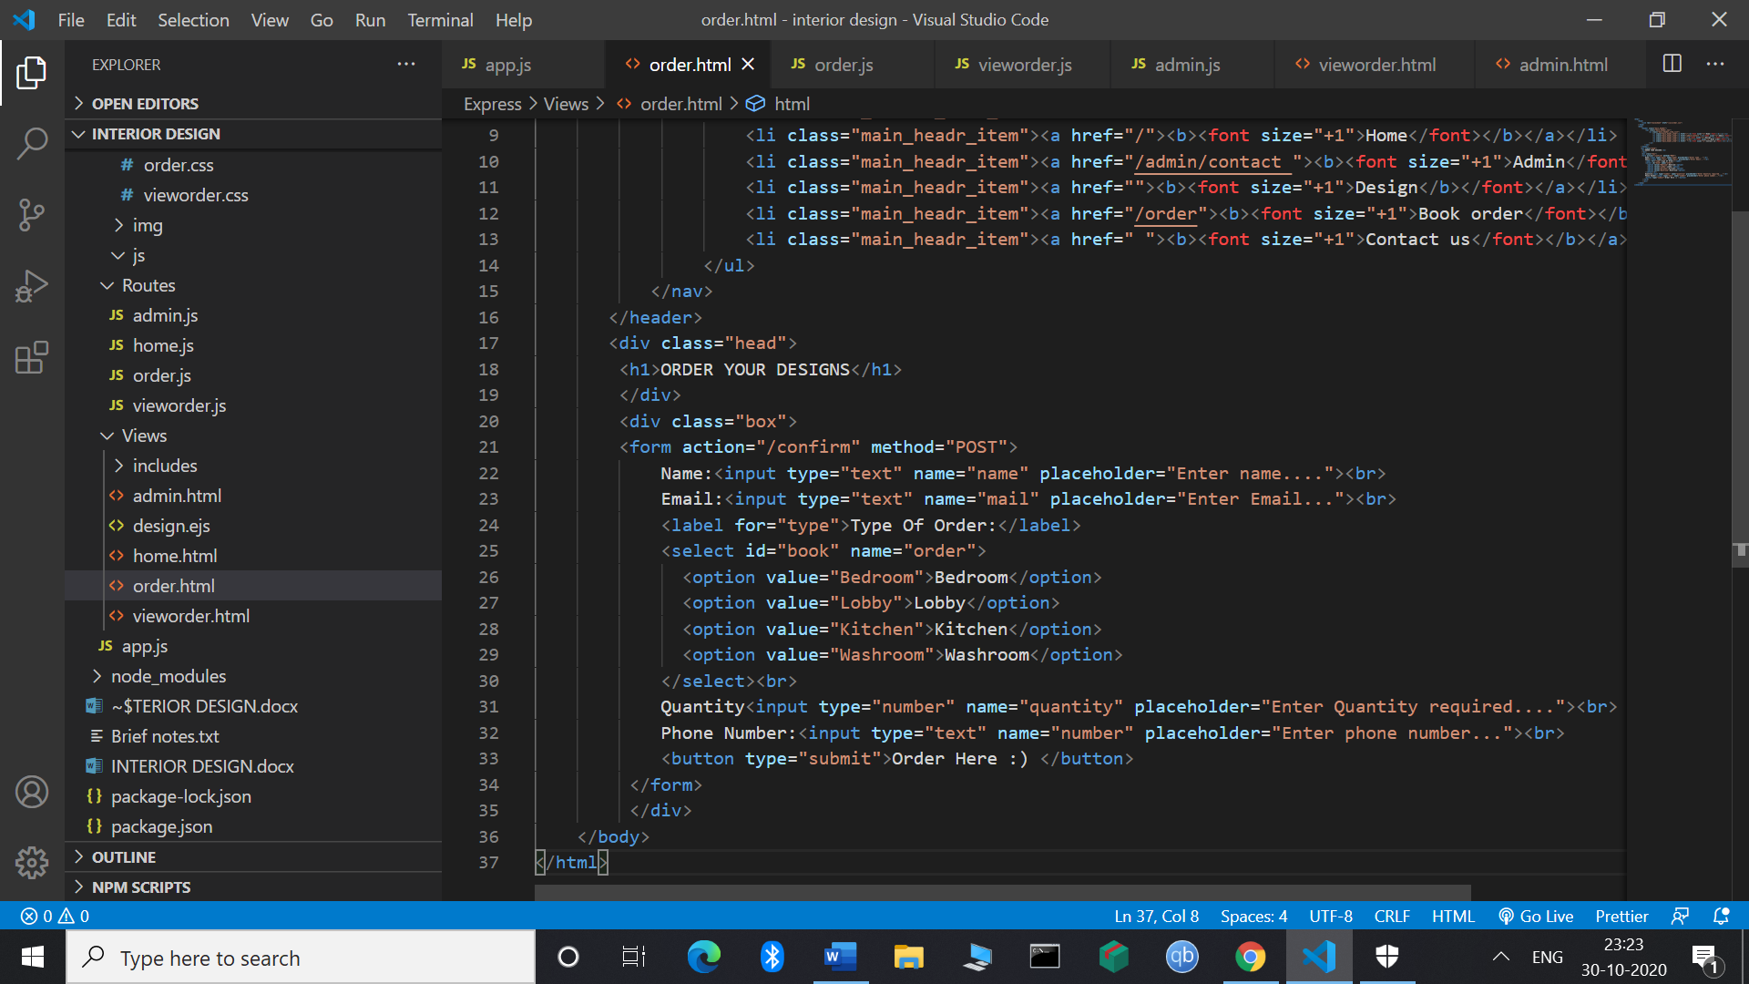

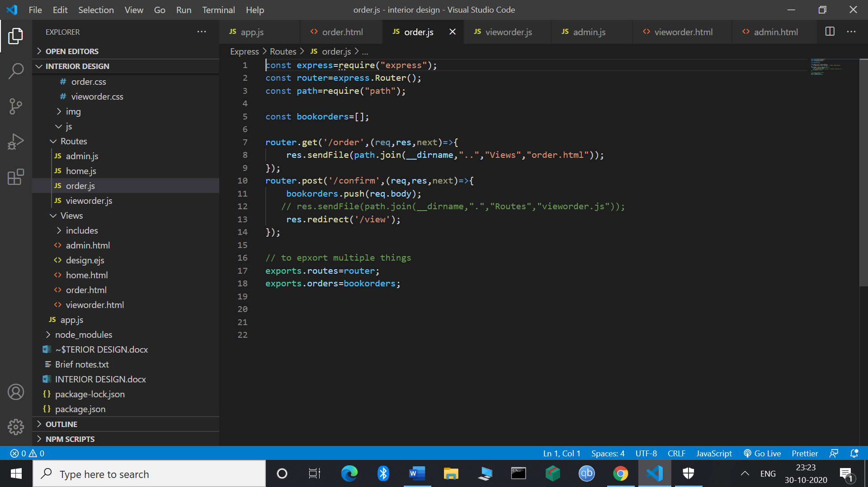

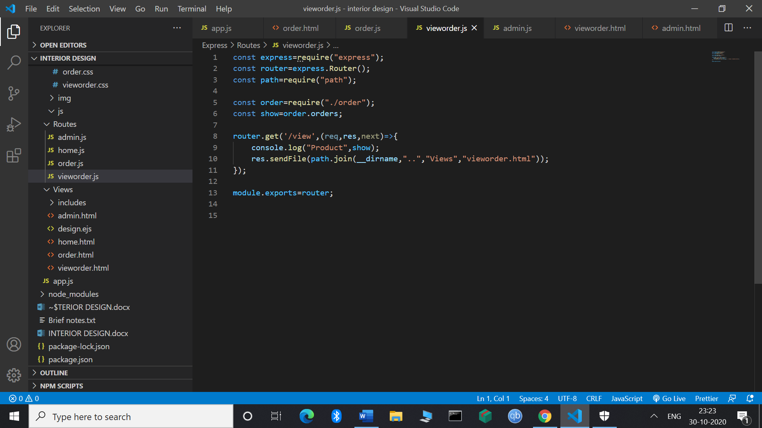

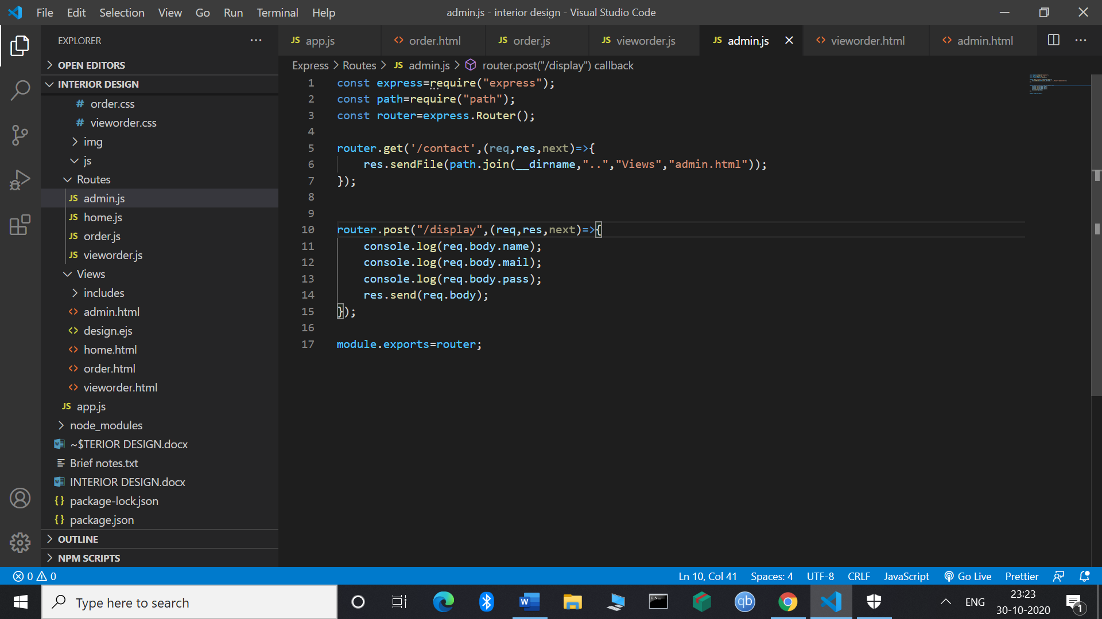

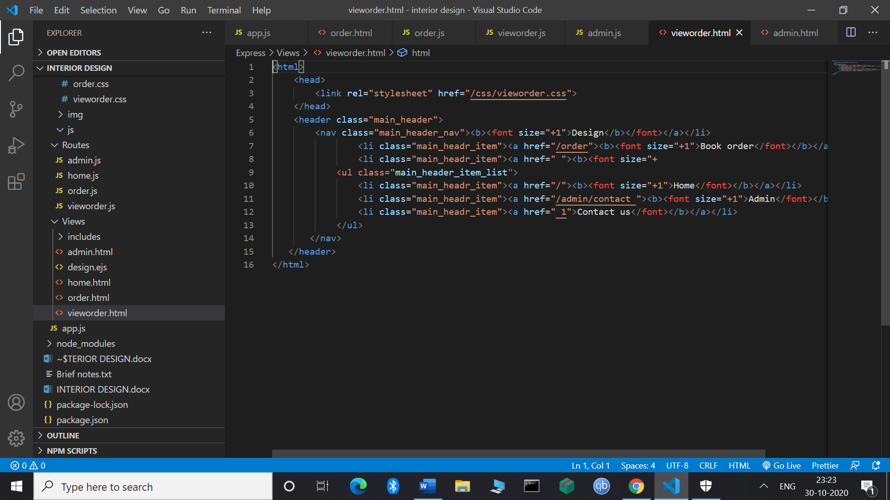

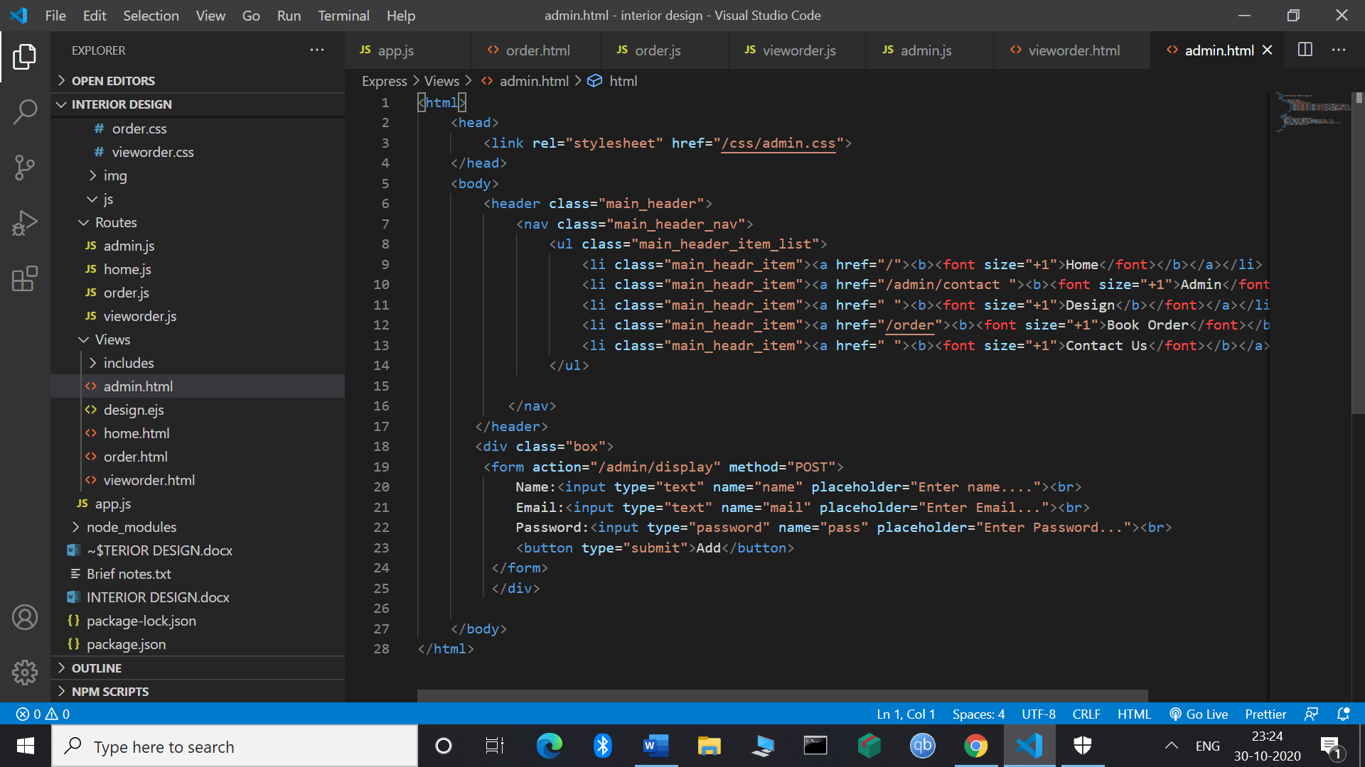

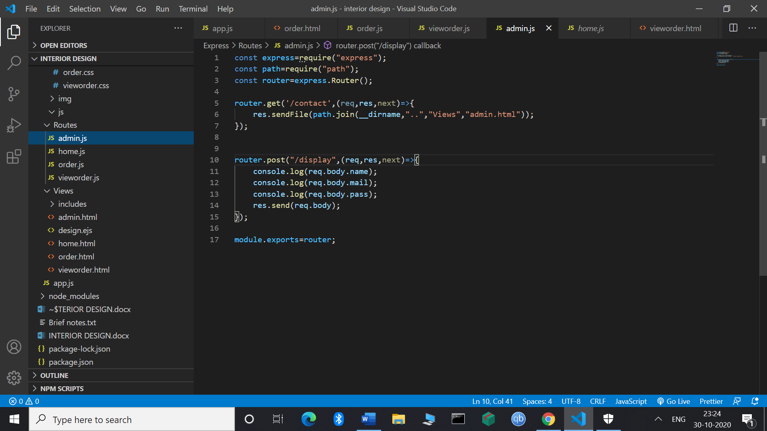

**EJS**

It is called as Embedded JavaScript. Its syntax is **<%=EJS %>**

**It will be USED** in place of the all the html files. Now all the html files will be converted into the EJS files. Now EJX is used. Here no need to change the HTML code here but where ever we want to print the data and in that case we will use the syntax of EJX. Here embedded JavaScript is used in this case.

**Effective, Easy and Elegant** as in this case we are not changing our HTML**.**

**App.set() It will assign** its value to the whole file. Here we want to fetch view-engine property.

Install it first of all by npm i ejs –save

App.set(“view-engine”,”ejs”)

app.set("view-engine","ejs");

Now in view folder we will have all the EJS files

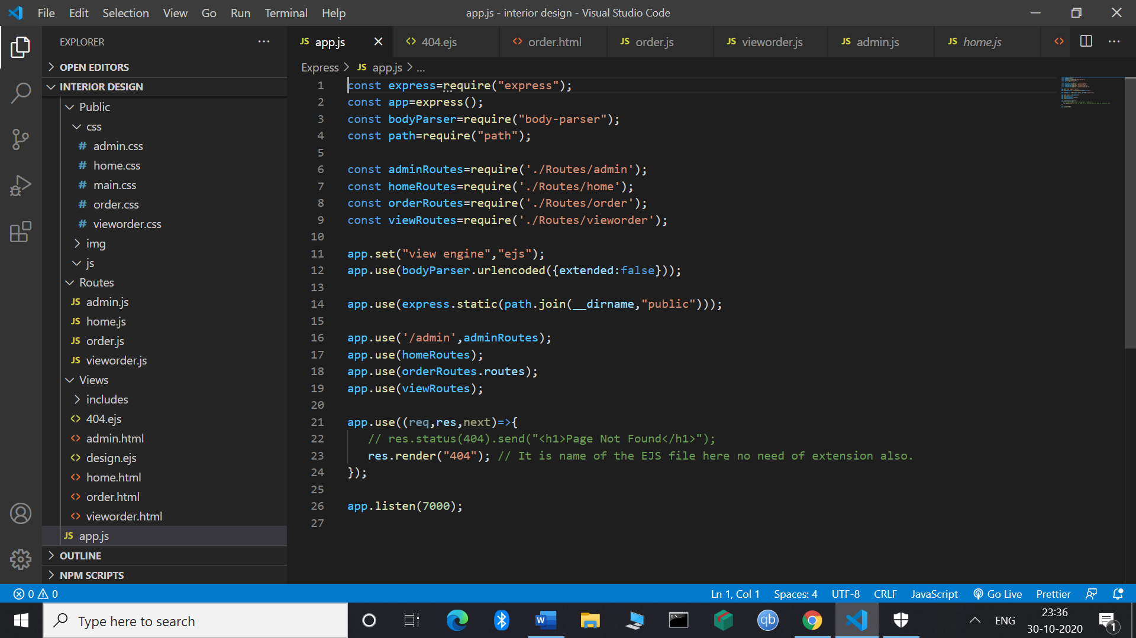

Here

Res.render(“404”); // It is 404.ejs file

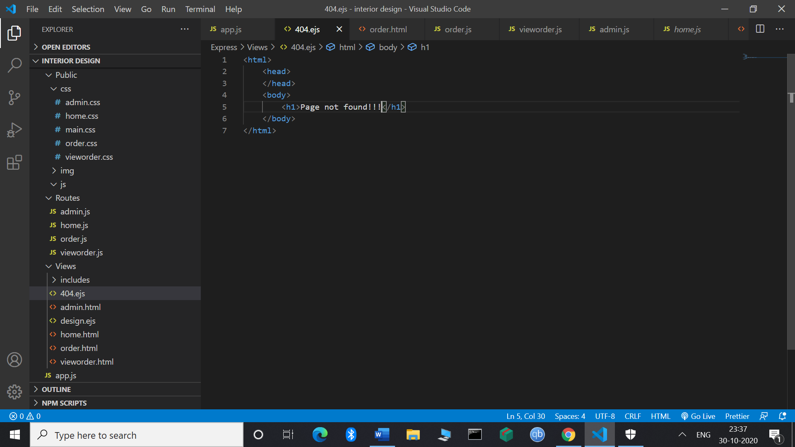

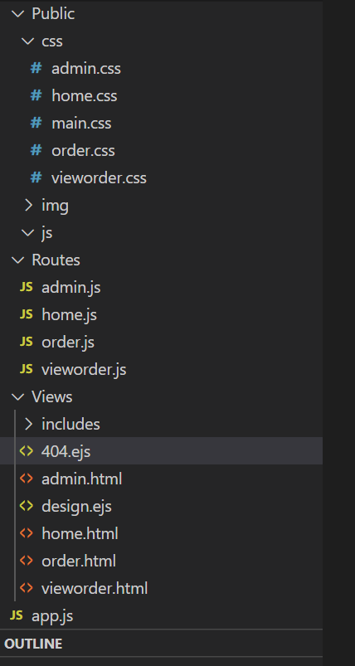

app.set("view engine","ejs");

This engine by default knows that All the ejs files are stored into the Views folder. Here res.render() will be used in this case.

Now we have to use res.render() method instead of res.sendFile(). Now we can directly send the res.render(“ejs file name”);

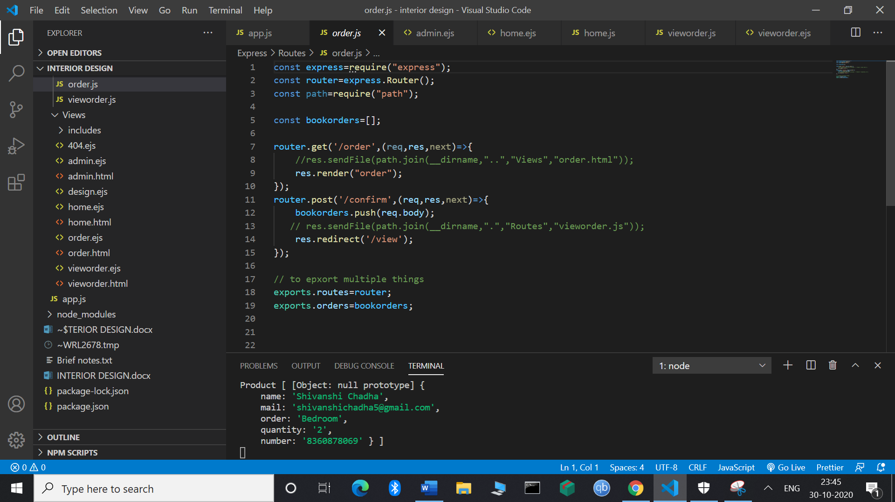

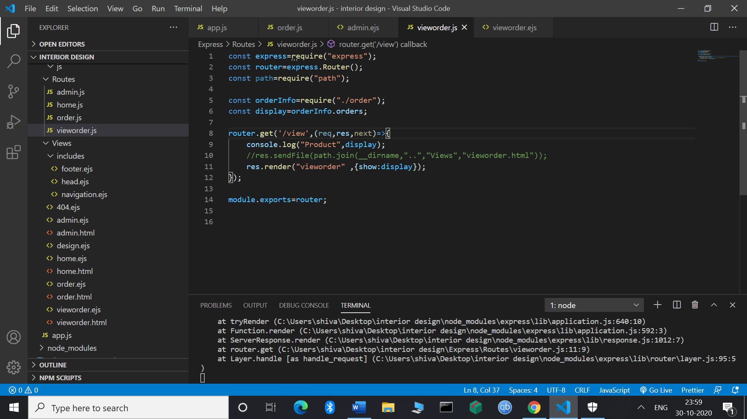

Here

 res.render("vieworder" ,{show:display});

Will have the second argument that will show the data on the browser.

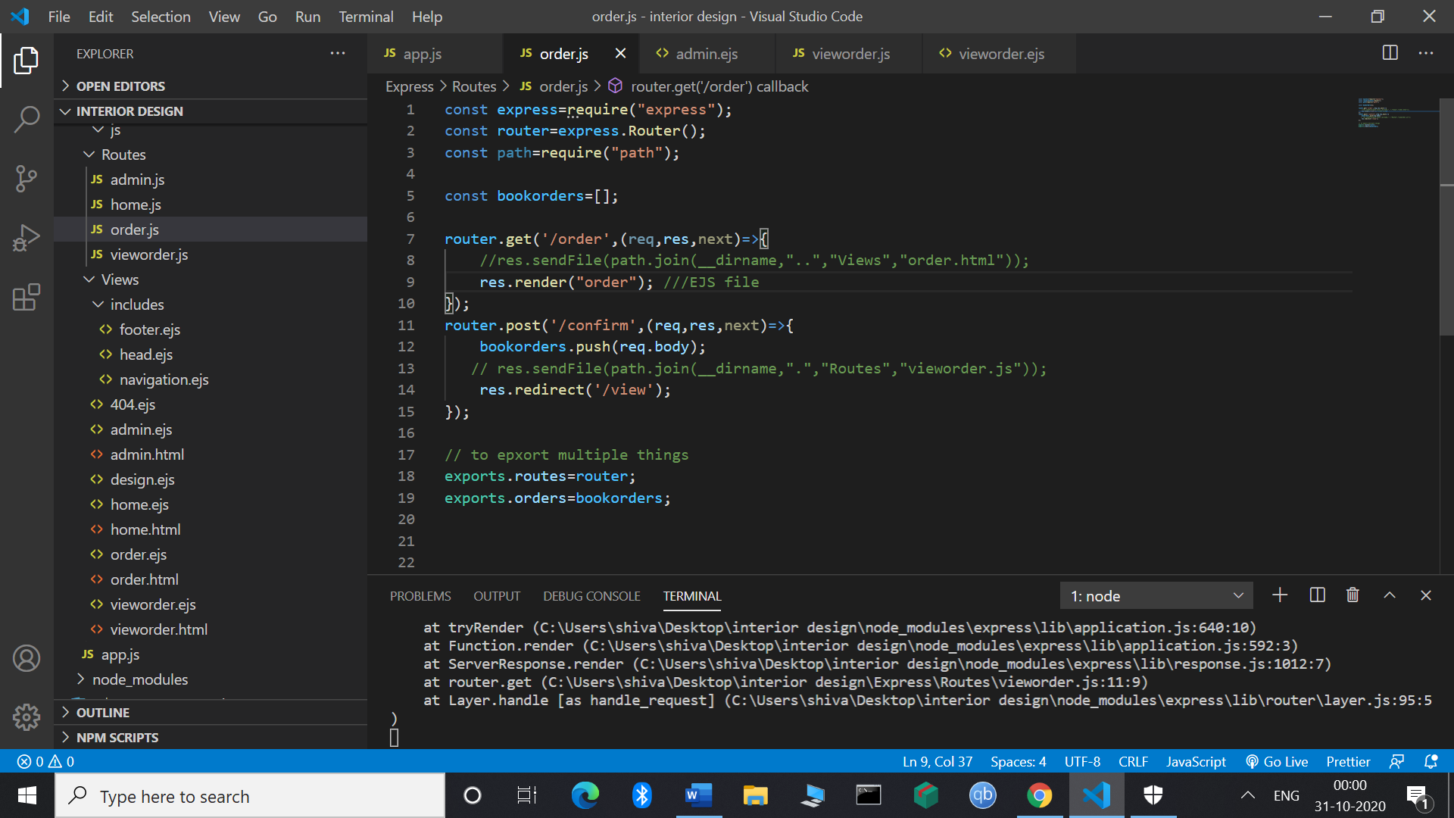

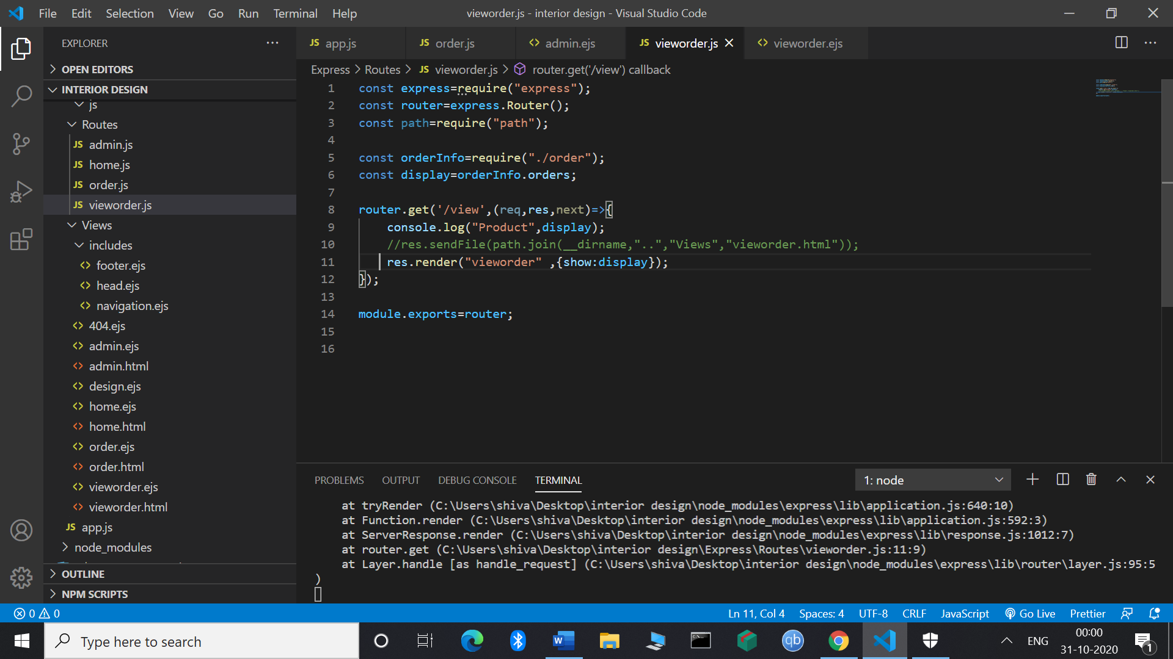

Here

res.render("vieworder" ,{show:display});

show is the variable that will display all the data that is fetched inside the array.

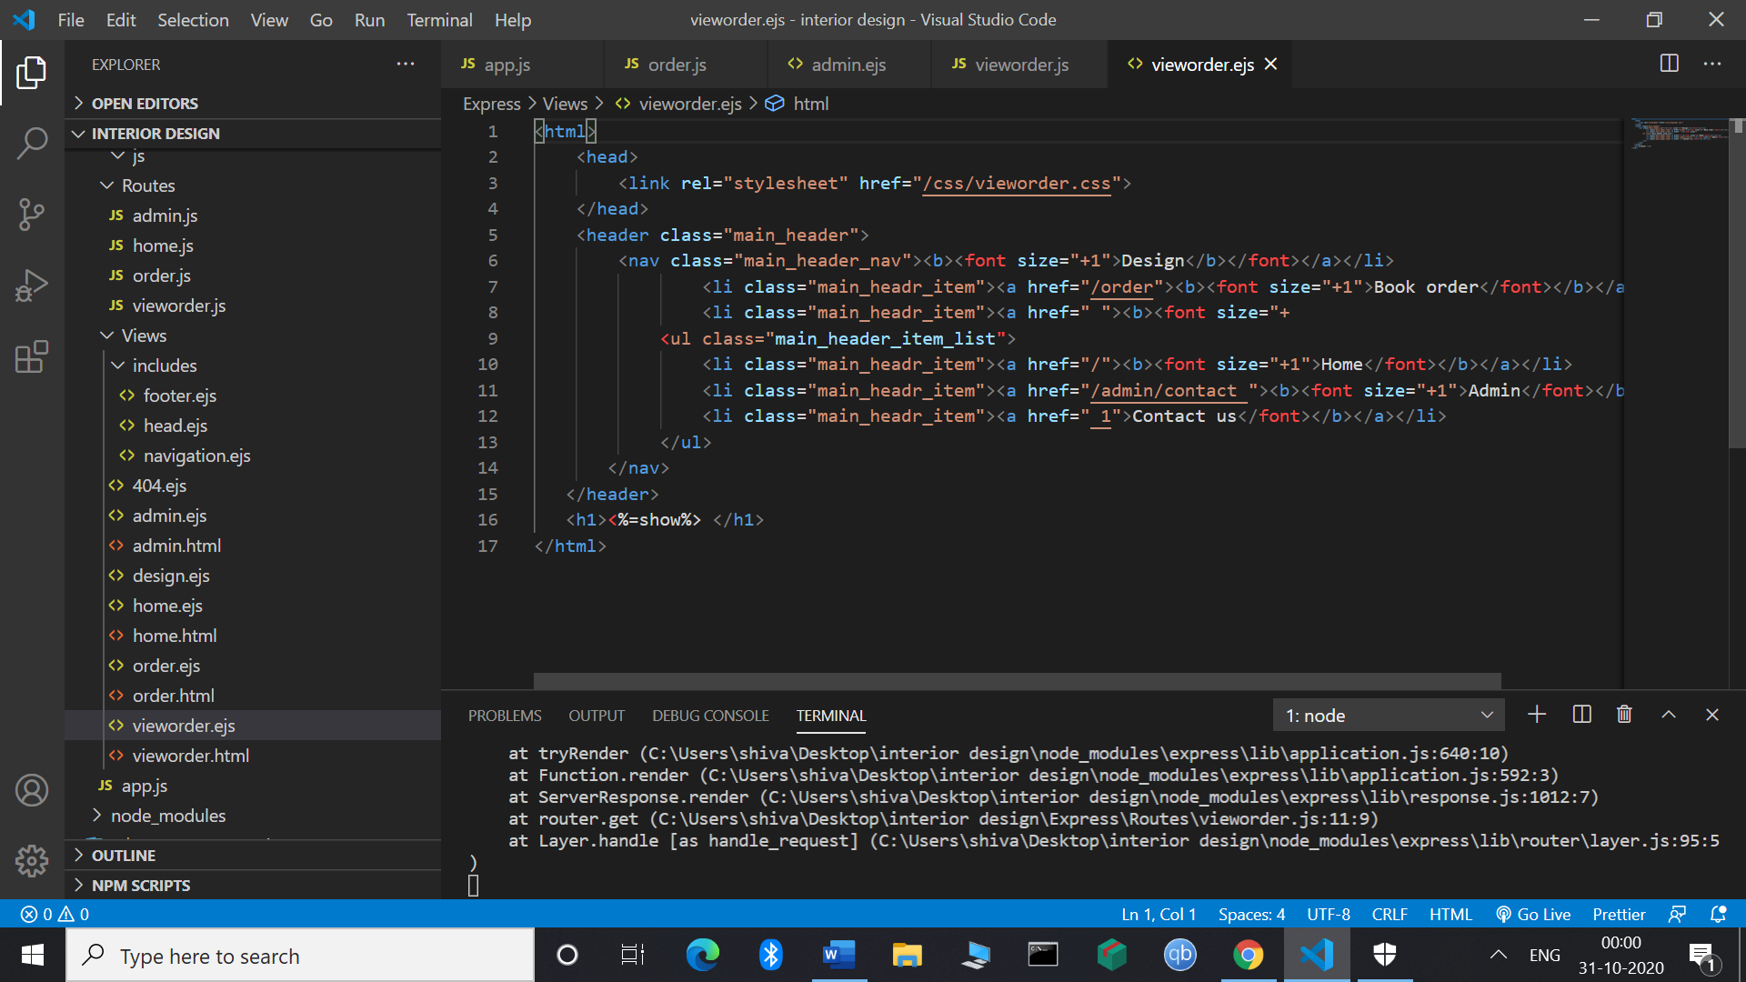

Here ejs file is there

<h1><%=show%> </h1>

It is the syntax of the ejs template to show the value.

TITLE SHOULD BE DISPLAY:- It should be dynamic

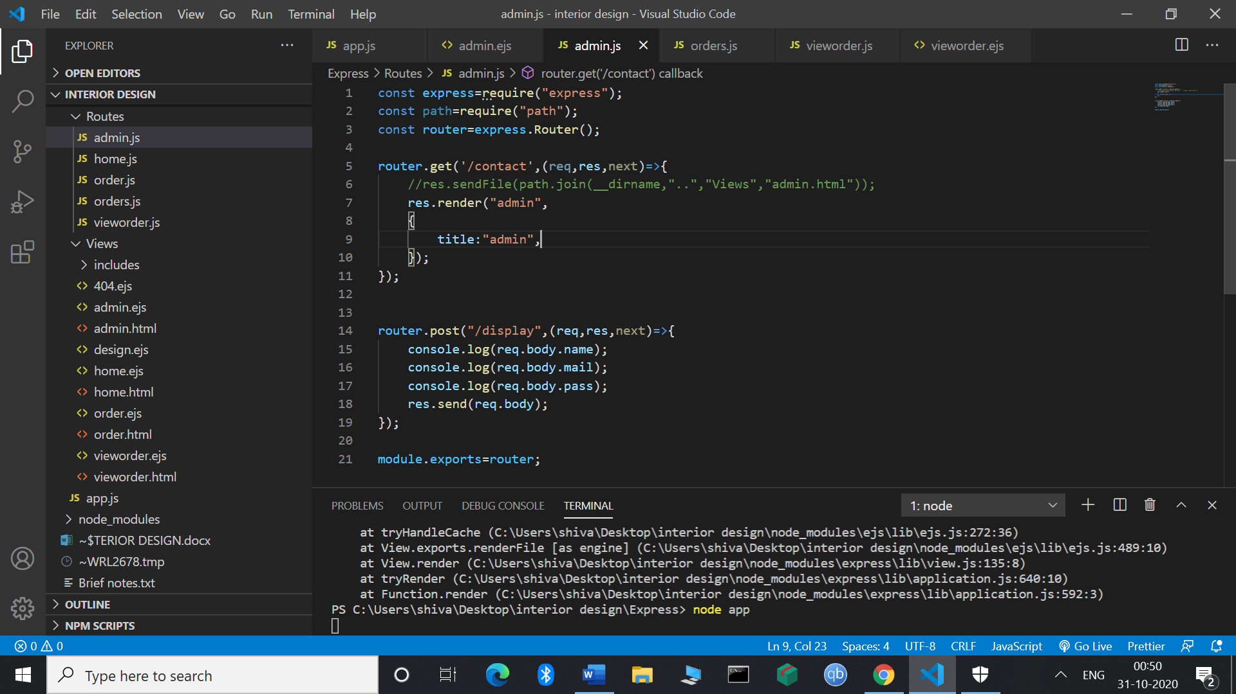

 res.render("admin",

    {

        title:"admin",

    });

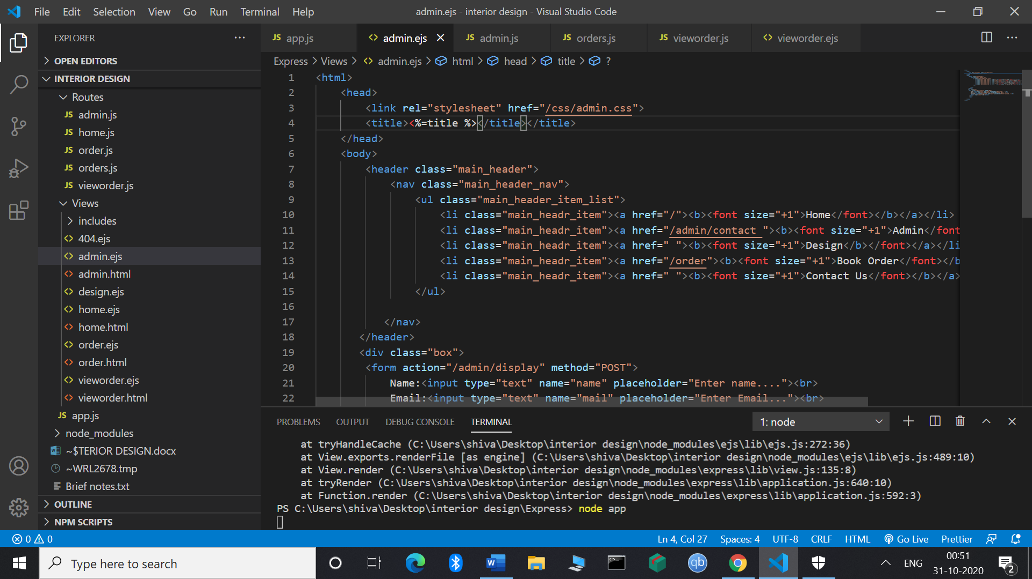

<title><%=title %></title>

1. Authentication

Npm i bcrypt

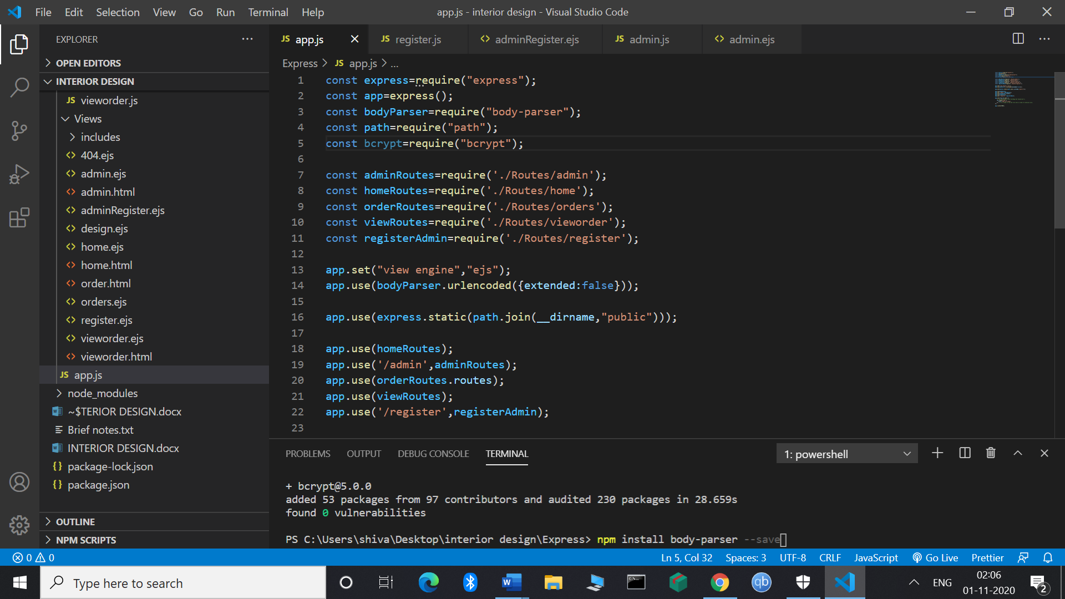

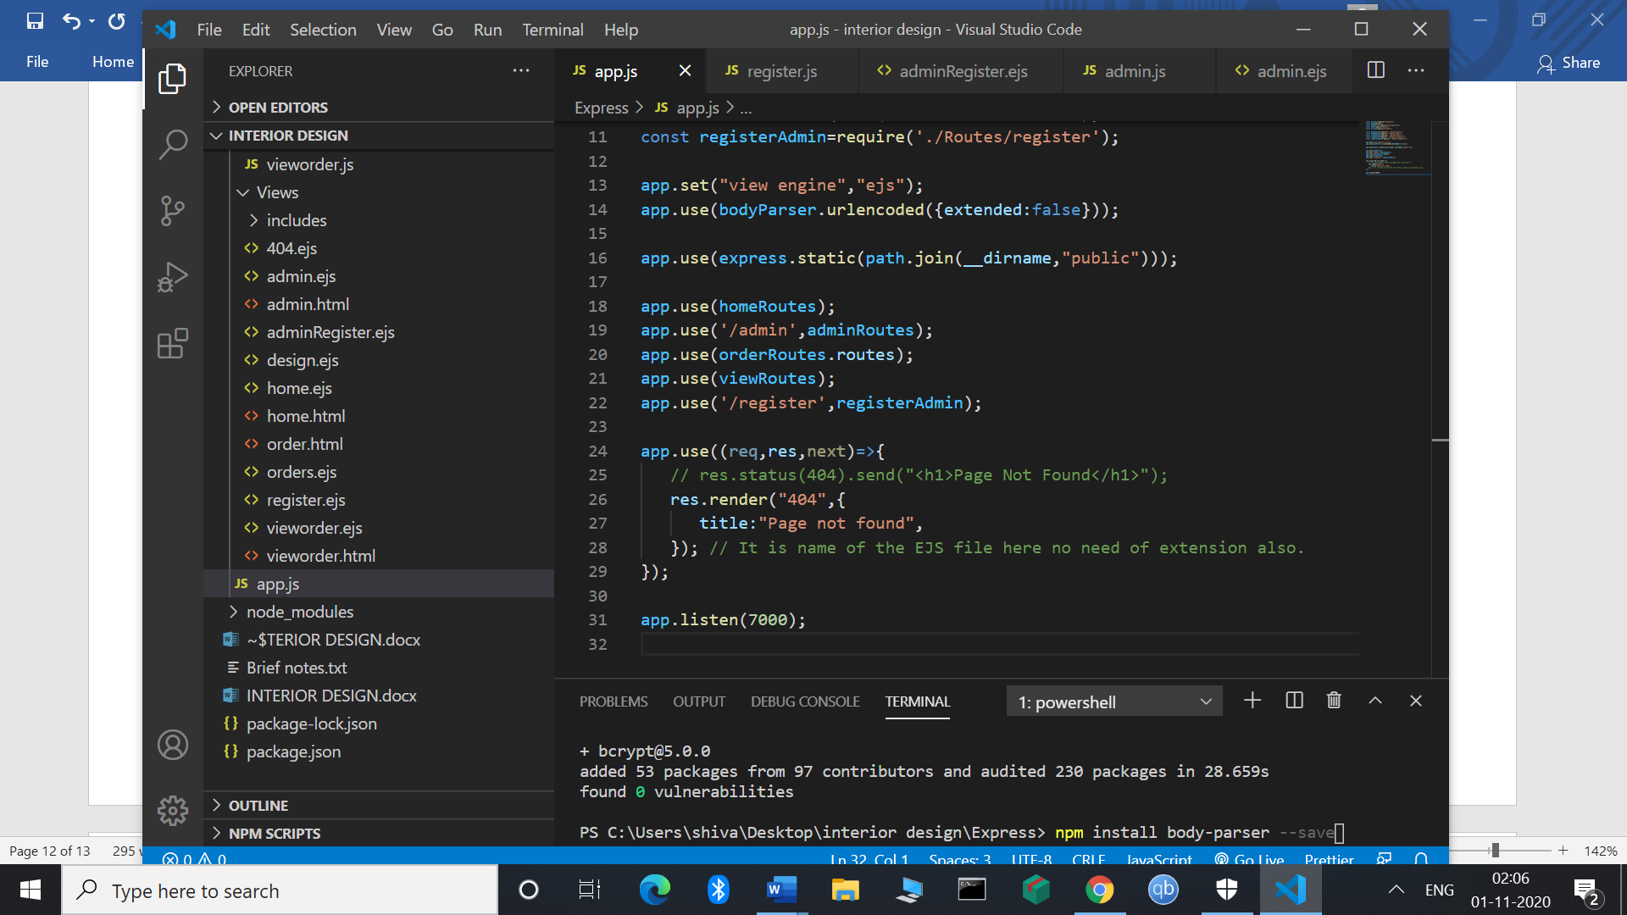

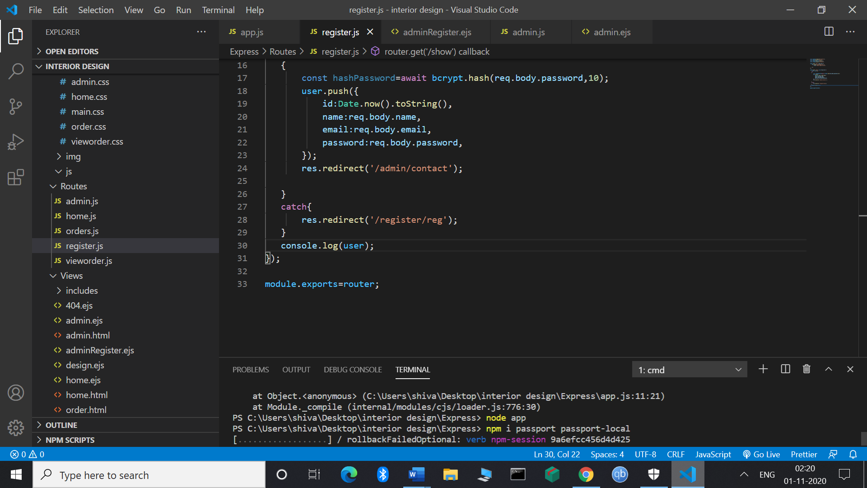

Npm I passport passport-local (It is used to access the local user name id and password)

